Submitted electronically via BLM e-Planning project website:
https://eplanning.blm.gov/eplanning-ui/project/2024165/510

Tracy Stone-Manning
BLM Director
Attention: Protest Coordinator (HQ210)
PO Box 151029
Lakewood, CO 80215

Re: Protest Regarding Proposed Final Resource Management Plan Amendment for the Río Grande del Norte National Monument

Dear Director Stone-Manning,

The Friends of the Rio Grande del Norte is a New Mexico based 501(c)3 Organization that believes that land protection cannot be fully realized without careful and meaningful land stewardship. We strive to facilitate a connection between the local community and the managing and governing agencies of our beloved National Monument. Through outreach, conservation, and access projects, we work to enhance the National Monument and the lives of the people who live, work and play in the Rio Grande del Norte.
We have worked hand in hand with community members, local stakeholders, NGO’s, and the Taos Field Office throughout the entire RMP planning process. We have submitted comments at both the scoping and draft EA phases of the planning process. We appreciate the efforts that the BLM and particularly the Taos Field Office has put forth to complete this RMP. However, we find that the final version of the RMP fails to meet the needs and concerns of the community, as well as fails to address concerns about protecting the objects of value described in the monument proclamation on these important issues-
- Expansion of ROWs
In reference to the expansion of the Right of Way(s) issue, Friends of RGDN submitted these scoping comments during the RMP amendment scoping period-
We are concerned by the BLM’s suggestion that new rights-of-way might be authorized in the Monument. To avoid habitat fragmentation and other unacceptable impacts on Monument objects and values, we urge the BLM to ensure that all new utility lines are sited in existing rights-of-way. New lines could be accommodated by designating existing rights-of-way for co-location. Additionally, any new, expanded, or upgraded utility rights-of-way should improve service to local communities and must be carefully designed in a manner consistent with the protection, preservation, and restoration of Monument objects.

Additionally, Executive Director Streit expressed concern and opposition to the expansion of ROW’s at the BLM’s public meeting in Taos, NM on May 7th, 2024.
We believe that the BLM has failed to address the concerns of the community and the protection of the objects of value in its proposed expansion of Right of Way Corridors across the Rio Grande del Norte National Monument. The Rio Grande del Norte National Monument Proclamation states,

Nothing in this proclamation shall be construed to preclude the Secretary from renewing or authorizing the upgrading of existing utility line rights-of-way within the physical scope of each such right-of-way that exists on the date of this proclamation. Additional utility line rights-of-way or upgrades outside the existing utility line rights-of-way may only be authorized if consistent with the care and management of the objects identified above.”

We believe the BLM has erred in their decision to expand ROW’s in the monument because the dramatic expansion of width of the ROW’s in the Monument would allow for utility lines large enough to negatively impact the viewshed of large sections of the monument and pose a threat to wildlife. The BLM’s proposed ROW designation lacks adequate support and justification in the record to demonstrate that the new ROWs will be “consistent with the care and management of the objects” that the Monument was designated to protect. In the Purpose and Need section, the BLM states that “Opportunities for new rights of way (ROWs) for electrical transmission in support of renewable energy development is an evolving circumstance that may require new authorizations consistent with the parameters specified in Proclamation 8946.” The BLM further explains that the ROW designation will allow for “new, expanded, and upgraded utility ROWs that serve local communities in a manner consistent with the protection, preservation, and restoration of Monument objects. Proclamation 8946, which established the Monument, allows for limited opportunities to upgrade or modify utility ROWs. The linear layout of the Monument makes it difficult to avoid crossing the Monument with transmission lines and other utilities.” The BLM’s conclusory statements that the ROWs will “serve local communities in a manner consistent with the protection, preservation, and restoration of Monument objects” is insufficient to meet the requirements of the proclamation and applicable law.

- Cerro de la Olla- Lands with Wilderness Characteristics
In reference to Cerro de la Olla Lands with Wilderness Characteristics, Friends of RGDN submitted these comments during the scoping process-
We strongly support the BLM’s proposal to manage Cerro de la Olla to protect its wilderness characteristics. The area covers approximately 13,000 acres, with the main feature being the Cerro de la Olla (“Pot Mountain”), an extinct shield volcano that rises to an elevation of 9,475 feet. The upper elevations of the volcano offer solitude and expansive views of the Sangre de Cristo and San Juan Mountains, and the dramatic Río Grande gorge
Cerro de La Olla provides critical habitat for elk, deer, black bear, mountain lion and a plethora of other wildlife. Because it is one of the few non-motorized and forested areas of the monument, wildlife thrives on Cerro de la Olla year-round. In 2017, the BLM inventoried the area and found that Cerro de la Olla boasted over 12,000 acres of land with wilderness characteristics. We believe that entire 12,236 acres that the BLM has inventoried should be managed to protect and maintain Lands with Wilderness Characteristics, and designated as such.
We believe the BLM erred in their decision to only manage 5,120 of the 12,236 inventoried as Lands with Wilderness Characteristics because the designation of the full 12,236 acres as LWC would not impair the Objects of Value in the monument proclamation. We understand that some considerations may need to be made in the exact boundaries of our desired LWC area of approx. 12,000 acres to accommodate for fuelwood harvest.

- The BLM should correct the language on page 21 that says BLM will “minimize impacts” to wilderness characteristics instead of “protect and maintain” wilderness characteristics.

In the discussion of alternatives, Section 2.4, the BLM states that under the proposed Monument Management Plan, the BLM would “[m]anage the Cerro de la Olla (5,120 acres) and San Antonio East (9,855 acres) units to minimize impacts on wilderness characteristics, while allowing compatible uses that are consistent with the protection of Monument objects.” The “minimize impacts” language is inconsistent with other parts of the proposed Monument Management Plan, which state that the LWCs at San Antonio East (9,855 acres) and Cerro de la Olla (5,120 acres) would be managed to “protect and maintain wilderness characteristics.”
We presume that use of the “minimize impacts” language on page 21 of the Final RMPA/EA is likely an inadvertent clerical error, and we request that the BLM correct this language to state that the BLM will manage the LWCs to “protect and maintain” the wilderness characteristics, consistent with other parts of the Monument Management Plan and Draft FONSI.

Additional Comments

Though not listed as alternative actions in the RMP amendment we believe that other lands inventoried by the BLM as having wilderness characteristics may need to be managed as such in the future to protect those characteristics. The 2017 inventory shows roughly 166, 000 acres of LWC’s in the monument (see attached table below.) We would ask that the BLM continues to asses these special areas and consider these locations on an individual basis (as was done with Cerro de la Olla) to re-asses threats and adverse impacts, so that they too remain highlighted and durably protected. As stated in the RMP, these lands contain relevant and important values associated with traditional Indigenous and Hispano spiritual and cultural significance, wildlife habitat, special status species, water quality and quantity, wetlands and scenic quality.

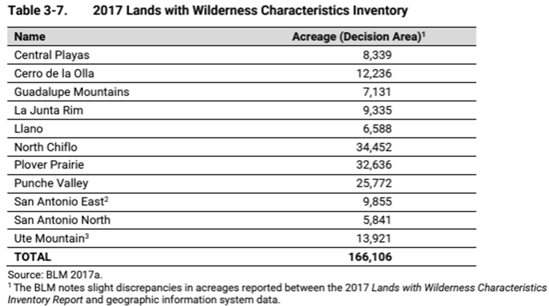

Conclusion

We would like to thank the BLM and especially the Taos Field Office for their dedication to this important RMP amendment. While we applaud the majority of the decisions and actions proposed, we respectfully protest the expansion of ROW(s), the decision to manage only 5,120 acres of Cerro de la Olla as LWC, and the language on page 21 that says BLM will “minimize impacts” to wilderness characteristics instead of “protect and maintain” wilderness characteristics.

Thank You,

Nick Streit
Executive Director
Friends of Rio Grande del Norte
5 Farrell, Ranchos de Taos NM 87557
nick@nmwild.org
575-751-6630

Attached Documents

Scoping Comments
Draft RMP Comments

