La Junta Trail Project
Friends of Rio Grande del Norte
Anticipated Project Cost $2,000,000

The La Junta Trail is one of northern New Mexico’s most iconic hikes, winding its way deep into the heart of the Rio Grande Del Norte National Monument to the confluence of the Red River and the Rio Grande. The Trail is approximately 1 mile long and navigates some very steep terrain. Due to safety concerns, the trail was closed to public use. The BLM realizes the value of this trail to local communities, visitors, and outfitters, and has made it a top priority to address the safety issue on the trail, and get it re-opened as soon as possible. Because of the difficult nature of the terrain, re-construction will be difficult and costly.

Working with several local Non-profit groups, the New Mexico Outdoor Recreation Division and our state and federal representatives, the Friends of Rio Grande del Norte National Monument aims to help the BLM re-open this important access point by securing funding for design, engineering, and construction. The BLM has already secured a feasibility study but lacks the funding and capacity to see this project through without our help.

La Junta Trail
The trail is approximately 1 mile long and switchbacks down a very steep ridge that divides the Rio Grande and Red River Canyons.
Due to its south facing exposure, it is commonly the only good access to the confluence in the winter months.
The trail is a popular destination for visitors, but also an important access point for local communities. Re-opening the trail will allow for traditional users to once again access the Rio Grande and Red River confluence for fishing, Pinon picking and herb gathering. The confluence area is also an important for local Hispano and indigenous communities.

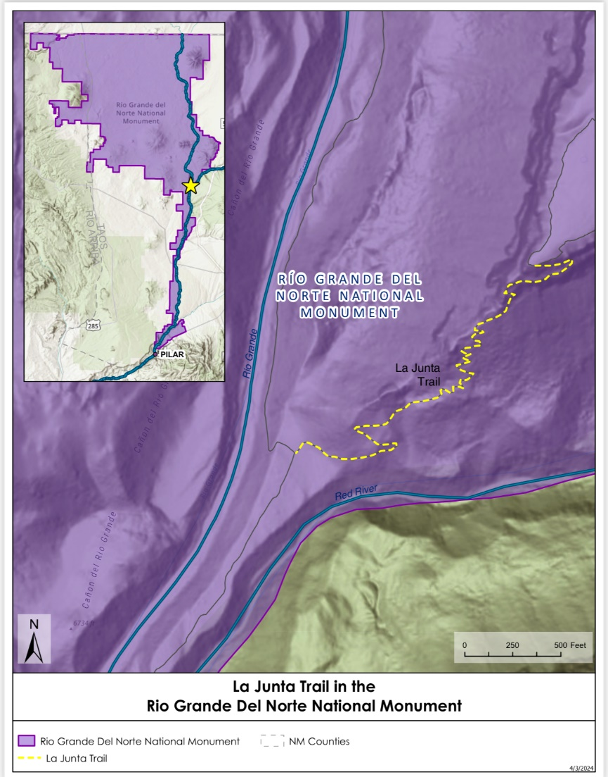

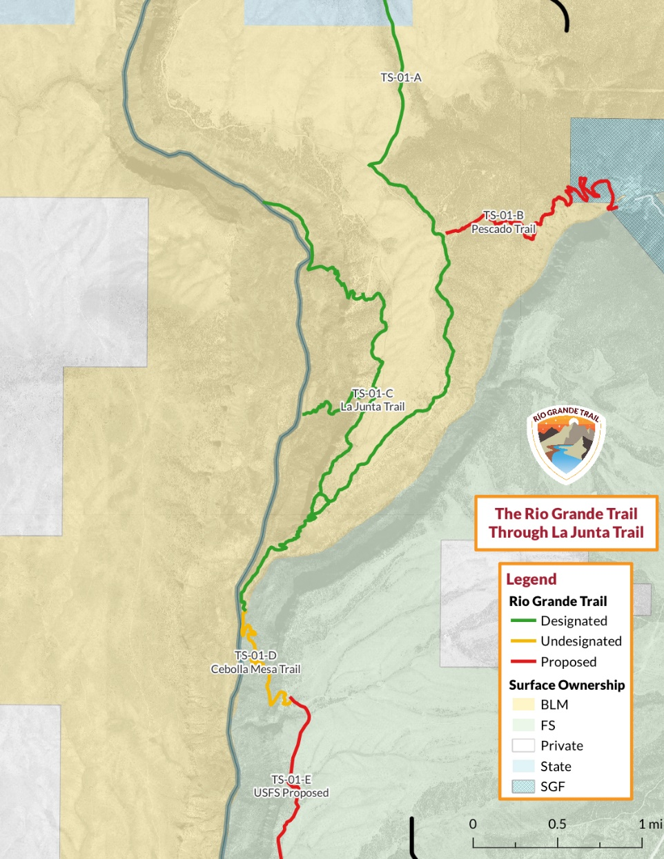
Rio Grande Trail
The La Junta Trail is a critical segment of the Rio Grande trail, a thru hike being developed by the state. It also connects to a network of trails in the Wild and Scenic Rivers area.
Before the area was included in the Rio Grande del Norte National Monument in 2013, it was a designated a Wild and Scenic River in 1968.
The La Junta trail accesses world class whitewater boating and fishing.

Action Plan
- Feasibility study with cost estimates – Completed.
- Secure funding for engineering- Trout Unlimited has partnered with Friends of RGDN and applied for a Trails+ grant through the New Mexico department of Outdoor Recreation. We expect to receive this grant and secure plans by the end of 2024.
- NEPA- The BLM office has made this a top priority, and has begun the process of fulfilling NEPA requirements. The Taos Field office expects this to be completed in a reasonable timeline, most likely by the end of the year.
- Funding for implementation- Friends of RGDN is working with our state representative to secure capital outlay funds in the next session at the start of 2025. Additionally, we anticipate receiving an additional Trails + grant through the New Mexico Outdoor Recreation Division. This should get us within $500,000 to $1,000,000 of our goal. We hope to leverage the money secured by the end of 2024 to leverage and match the remaining dollars.

